Experiment 6,7: Harmonic Oscillator, Part II. Physical Pendulum and Waves on a String

Amanda Wei

505 106 664

06/07/2019

Thursday 8am

Steve Mendoza

John Field

**Harmonic Motion in Physical Pendulums and Waves of a Vibrating Spring**

Amanda Wei1

Harmonic oscillation models the motion of a wide range of behaviors of physical systems, from pendulums to waves on a physical string. The properties of oscillators and how they respond to external forces such as damping and driving forces were studied. In the first part, the three regimes of damping were investigated using an aluminum pendulum whose motion was damped by magnets placed at the bottom near the equilibrium point. The three regimes observed were underdamped, overdamped and critically damped oscillations. Next, the pendulum’s response to a driving force was examined and two methods were used to determine resonance frequency, quality factor Q and time constant τ. Moving onto the harmonic behavior of waves on a thick string, the first motive was to determine how wave speed through the string was affected by the tension in the string. To this end, various masses were attached to the string and vibrations were sent through the string. By fastening the string to the pulley with the 0.5 kg mass, the behaviors of standing waves were observed. Frequencies at the fundamental, second and third modes were measured and were found to match well with the predicted frequencies.

1*Department of Physics and Astronomy, University of California, Los Angeles*

**Introduction**

Harmonic motion is the periodic variation of a system relative to an equilibrium point. In order to investigate the behaviors of physical harmonic oscillators and their properties, two experimental configurations were set up—one to observe the motion of an anchor-shaped pendulum and another to observe waves traveling through a tensed string.

In the setup of a swinging aluminum pendulum, we were primarily interested in its response to damping and driving forces. To achieve the behaviors expected in underdamped and overdamped regimes, the spacing between the magnets were adjusted in 10 mm increments beginning at 50 mm, and stopping at a 10 mm. To achieve critical damping, fine-tuning of the separation of magnets was needed, such that the angular velocity does not change sign after being released. Another method used to determine the resonance frequency used Lissajous figures, which plotted light intensity detected by the photodiode against the output voltage generated by the wave driver. At resonance frequency, the figure is expected to be most symmetrical about the y-axis. Thus, the driving frequency was adjusted and the Lissajous figures were plotted simultaneously until a most symmetric plot was produced.

The second experimental set up observed the behaviors of vibrations in a thick string generated by a wave driver. The vibrations were detected and recorded by a photodiode which measured the varying intensities of laser light scattered by the vibrating string. Part one was concerned with the speed at which waves propagated through the string. Predicted values for wave speed were consistently greater than the measured values, but an increase in the tension in the string correlated with faster propagation through the string, which was expected. Then the frequencies of the second and third modes were predicted by taking multiples of the fundamental frequency, and these were compared with the measured frequencies.

**Methods**

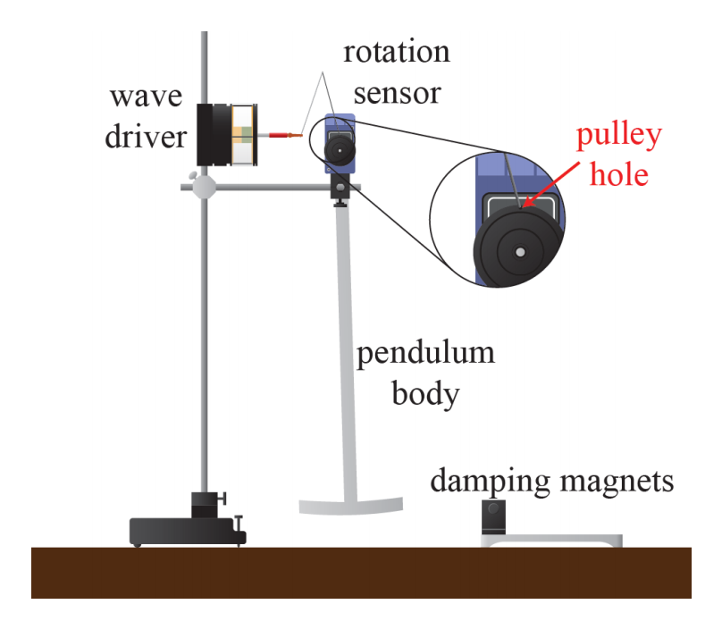

**Figure 1. Experimental Setup for Examining Damping Effects on a Physical Pendulum.**

***Physical Pendulum***

*Part I: Harmonic motion with damping*

A metal pendulum in the shape of an anchor was set up with a “wave driver” to set it into periodic motion, and a rotation sensor was set up at the top to measure the amplitude of the pendulum as it oscillated similar to what is illustrated in figure 1. To create a damping force, magnets were placed on either side of the equilibrium point of the pendulum at various distances (10 mm, 20 mm, 30 mm, 40 mm, 50mm). The first trial is conducted for an undamped oscillator (magnets are removed so there is no damping force).

The DAQ software was set up and connected to the wave driver and rotation sensor, with a sampling rate of 20 Hz. Output channel one is configured to be an Output Voltage Current Sensor, which monitored the phase of the drive signal. Then the pendulum was set into motion by releasing the anchor from a height such that the angle between the pendulum and its equilibrium is small enough to be able to apply the small angle approximation, $sinθ=θ$. The pendulum is released from this same position for every trial. Two columns of raw data were produced—one which recorded time and one for the angle measured at that time. To center the angular data, Zero Sensor Measurements at Start was unclicked and Zero Sensor Now was clicked when the pendulum was in its equilibrium position before every trial.

From the raw data, graphs of pendulum angle versus time are created. To achieve critical damping, the spacing between the magnets is adjusted until the angular velocity of the displaced pendulum no longer changes sign.

*Part II: Harmonic motion with driving*

The magnets are placed such that the magnets become a low source of damping just enough so that the oscillation is observable but still damps out fairly quickly, say 30 mm. The wave driver will be producing a sinusoidal driving force, and the drive voltage is kept below 5V. After the rotation sensor is zeroed while the pendulum is at equilibrium, it is set into motion and a table is generated in Capstone recording output voltage of the driver and angle of the pendulum. From this data, a Lissajous figure can be produced with the Output Voltage on the x-axis and Angle on the y-axis. If the pendulum is at resonance frequency, the plot is expected to be symmetric and circular. Even small deviations from resonance frequency will introduce an elliptical tilt in the plot.

In examining the amplitude response of the oscillator as a function of frequency, amplitude was recorded using the rotation sensor for various driving frequencies, and a resonance curve was produced with Oscillation Amplitude in radians on the y-axis and Driving Frequency in Hertz on the x-axis.

***Waves on a Vibrating Spring***

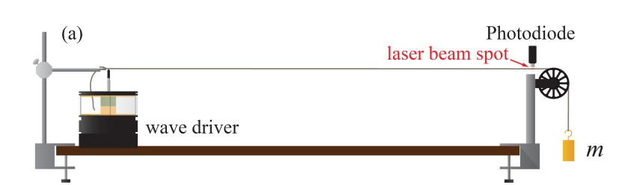

**Figure 2. Experimental Setup for Observing Waves on a Vibrating Spring.** As shown, a length of thick string is stretched taut over a wave driver and a pulley with a weight attached at the end. A laser illuminates a point on the string, and the photodiode detects the signal strength which is affected by how much of the laser light is scattered as the string vibrates. As the string moves down, less light gets scattered into the detector and the photodetector records a lower signal.

Since the weight of the thick string is non-negligible, the mass on the right is not the only source of tension in the rope. So the length and mass of the rope was measured.

The DAQ is set up such that one analog channel is set to read signals from a light sensor, and another output channel is set to send signals to the wave driver. The Signal Generator is set to run the wave driver sinusoidally at 5 Hz at 1V of output. As the string is vibrating, three columns of data are collected: time, output voltage at a moment in time (measure of driving force) and light intensity (measure of vertical position of the string as it is vibrating).

*Part I: Wave speed*

The speed is measured for varying tension applied to the string. Since applying greater tension will stretch the rope, the linear mass density will not be the same each time, so before each trial the length is measured. In Capstone, data collection is set to Continuous, signal generator to Auto, waveform to Square (as opposed to Sine), frequency of data collection to 0.2 Hz, and Amplitude to 1V.

Three columns of data are collected for each run—time, wave driver voltage and light intensity.

*Part II: Standing waves*

To find the resonant frequency for the fundamental mode of the stretched string, the frequency of the wave driver is adjusted to maximize the amplitude of the oscillating string. Using the resonant frequency for the fundamental mode (*n*=1), the resonant frequencies can be obtained for higher modes by taking it to be *n* times the fundamental frequency.

Lissajous plots are created by graphing output voltage of the wave driver on the x-axis and light intensity on the y-axis. At resonant frequency, the lissajous plot will be symmetric. To find the uncertainty in the measurement of resonant frequency, modify the driving frequency by a little above and below the measured resonant frequency until a distortion in the Lissajous plot is observed. How much the frequency was changed until the distortion is observed is the the uncertainty.

At higher frequencies, the amplitude became harder to observe so in Capstone, Amplitude was increased from 1V to 5V.

*Part III: Boundary effects*

For the third part, the string was set to the resonant frequencies for *n*= 1, 2, and 3. The amplitude of the vibration is taken to be the peak to peak extrema of the light intensity, since the variation in amplitude will be proportional to this. For each mode, a ring stand and post constrained the middle node on the string, and the new amplitude is measured.

**Analysis, Oscillation of a Physical Pendulum**

*Part I: Damped Harmonic Oscillation*

Derivation of $w_{damped}$:

Variables:

$θ$: angle between pendulum and the vertical (equilibrium position)

*M*: total mass of the pendulum

*l*: distance between rotation axis and center of mass

Restoring torque due to gravity:

$τ_{grav}=-Mglsin(θ)$

The spring attached at the top exerts a torque on the pendulum. This is given by:

$τ_{spring_{}}=-Bsin(θ)cos(θ)$

Damping torque produced by the magnets is proportional to angular velocity. It is given by:

$τ_{damping}=-bθ'$

A differential equation that describes the motion of the pendulum is:

$Iθ''=-Mglsin(θ)-Bsin(θ)cos(θ)-bθ'$

Since the pendulum is released from a small angle from equilibrium, $sin(θ)≈0$ and $cos(θ)≈1$.

Then, the differential equation can be simplified to:

$Iθ''≈-kθ-bθ'$

And a solution $θ(t)$ is:

$θ(t)=Ae^{i\sqrt{\frac{k}{I}-\frac{b^{2}}{4I^{2}}t}}×e^{-bt/2I}=Ae^{iw_{damped}t}×e^{-t/τ}$,

where

$ω_{damped}≡\sqrt{\frac{k}{I}-\frac{b^{2}}{4I^{2}}}=\sqrt{ω_{o}^{2}-\frac{1}{τ^{2}}}$ and

$τ≡\frac{2I}{b}$, and $w_{o}=\sqrt{k/I}$.

If:

$ω_{o}>\frac{1}{τ}$, then the oscillator is underdamped.

$ω_{o}<\frac{1}{τ}$, then the oscillator is overdamped.

$ω_{o}=\frac{1}{τ}$, then the oscillator is critically damped.

The three regimes are illustrated in the figure below.

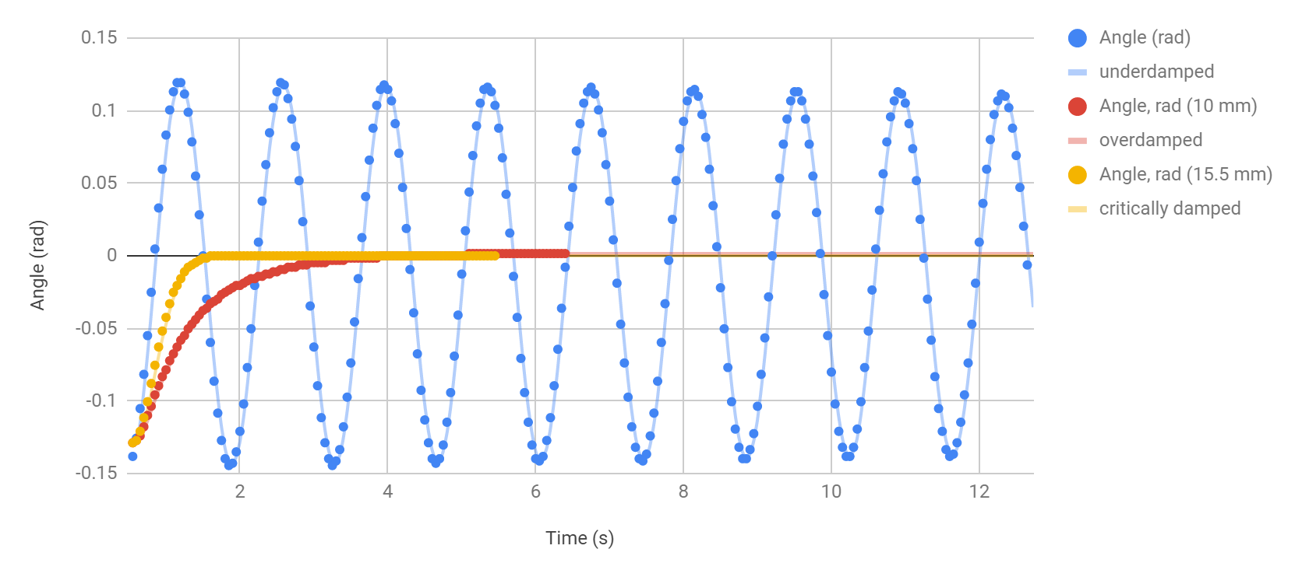

**Figure 3. Physical Pendulum Oscillation Under Various Regimes.** By placing the magnets at various distances, the oscillator differed in its behavior. Each plot represents the amplitude of the oscillating pendulum with varying damping forces from the magnets as a function of time. In the undamped trial, the magnets were removed completely and the pendulum was allowed to oscillate freely. Its motion is shown in blue. In the trial of overdamped oscillation, the magnets were spaced $10±0.05 mm$ apart and it is represented by red. Lastly, the yellow represents the critically damped oscillation where the magnets were spaced $15.5±0.05 mm$ apart. The critically damped oscillator reached equilibrium faster than oscillators in either of the other two regimes.

The undamped resonance frequency is given by the average of the frequency from peak to peak:

$ω_{o}=\frac{n-1}{t_{n}-t_{1}}=0.710$

The uncertainty in frequency is given by the following formula for systematic uncertainty:

$δω_{o}=\frac{STDEV(ω_{o})}{\sqrt{n}}=\frac{0.0072}{\sqrt{2}}=0.005$

The value of the undamped resonance frequency, including uncertainty is then:

$ω_{o}=0.710±0.005 Hz$

*Part II: Harmonic Motion with Driving Force*

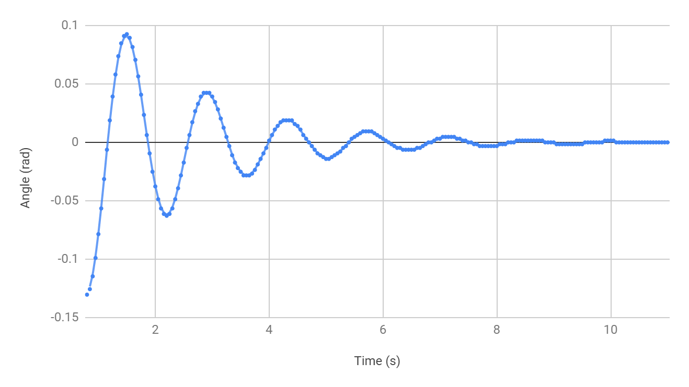

**Figure 4. Motion of a Harmonic Oscillator with Driving Force.** This plot shows the oscillation of the pendulum in terms of its angle formed with the vertical as a function of time. In this configuration, the magnets were spaced $30.0±0.05 mm$ apart, so the oscillator reached steady state after around ten seconds.

Driven oscillators have an extra term in the differential equation which models its behavior. For a driving force with frequency $ω_{d}$ differential equation looks like:

$Iθ''=-k-bθ'+Ccos(ω_{d}t)$

The resonance frequency, $ω_{R}$, is the driving frequency which maximizes the amplitude of oscillation. Solving the differential equation and differentiating the solution, $ω_{R}=\sqrt{{ω_{o}}^{2}-2\frac{1}{τ^{2}}}$

To find damping time $τ$, use formula

$τ=-\frac{T}{ln|r|}$, for $r≡\frac{θ(τ+T)}{θ(t)}$ and *r* is the ratio of successive amplitudes.

$ω_{o}$ was already determined to be $0.710±0.005 Hz$.

Since period T is the inverse of frequency, $T=\frac{1}{ω_{o}}=1.408±0.01 s$.

To find $τ_{avg}$, take the average of the $τ$ values where *r* is taken to be the average between each successive extrema. Then, $τ_{avg}$ is taken to be the average of these values of $τ$, and the uncertainty in $τ$ is determined by $\frac{STDEV(τ_{avg})}{\sqrt{7}}$

Then,

$τ=-\frac{T}{{ln|r}_{avg}|}=1.903±0.10 s$

The uncertainty in resonant frequency $ω_{R}$ is given by:

$δ(x^{n})=|x^{n}||n|(\frac{δx}{|x|})$

$δ(x+y)=\sqrt{(δx)^{2}+(δy)^{2}}$

Then $ω_{R}=\sqrt{(-0.0481±0.0299)s^{-2}}$

The prediction predicts a complex number for the resonant frequency, and the damping time must be less than the damping time for a critically damped system. This could be attributed to errors in experimental set up. While this prediction breaks down, there are two other ways of calculating Q, illustrated below.

Another way to find resonance frequency $ω_{R}$ is to plot Lissajous plots and identify the driving frequency where the graph is most symmetric. The following graphs were produced from Output Voltage and Angle values taken from trials where the damping force was adjusted slightly in order to determine the resonance frequency and uncertainty.

(a)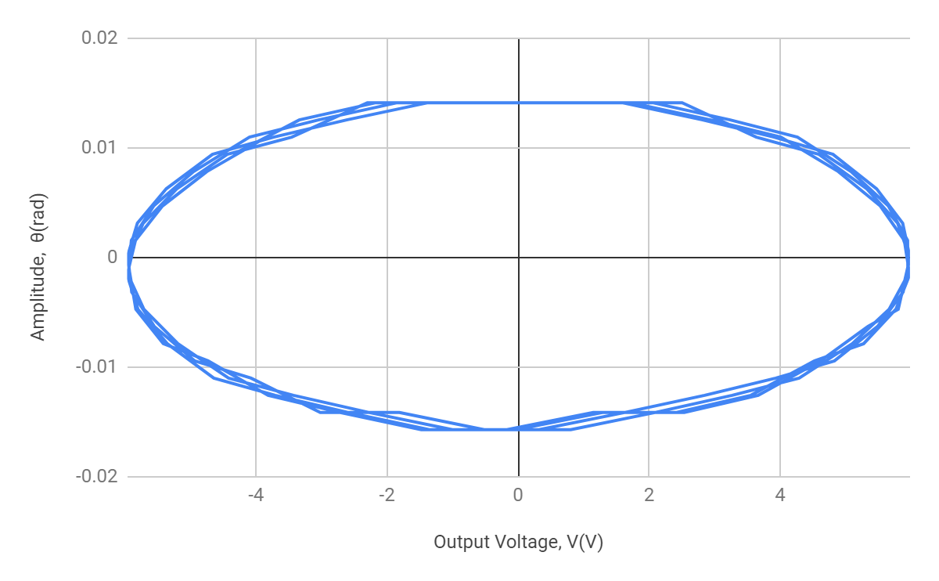(b)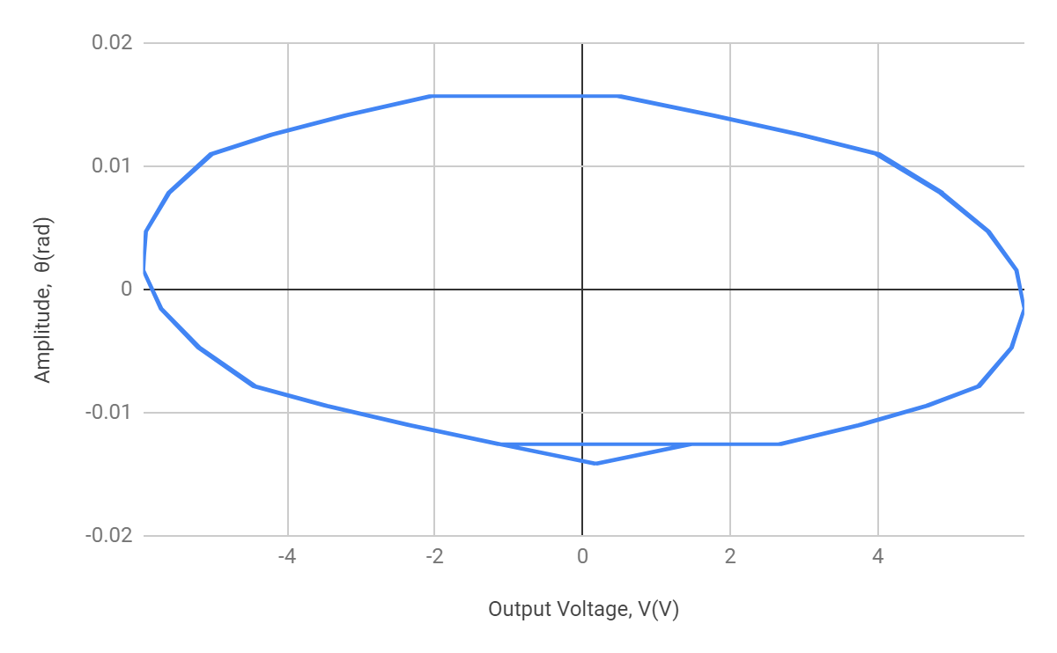

**(c)**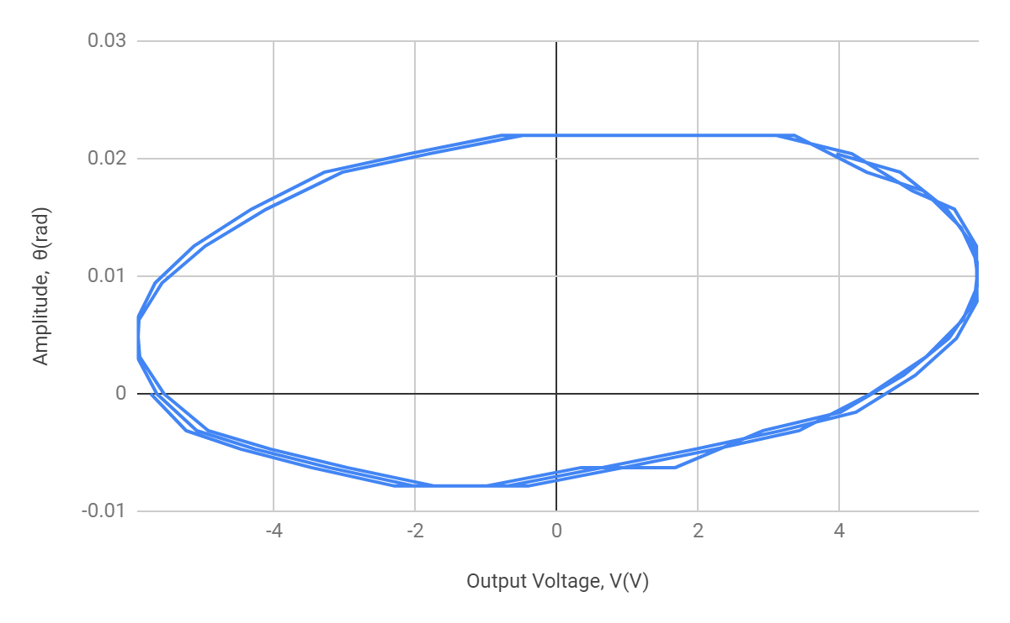

**Figure 5. Lissajous Plots for Frequencies Near Resonance.** These three plots plot the amplitude of the oscillation of the pendulum in terms of radians as a function of the output voltage generated by the wave driver. In plot (a), the wave driver is set to resonance frequency at $ω_{R}=0.705±0.005 Hz$. The wave driver is set to $ω_{}=0.690 Hz$ in plot (b) and $ω_{}=0.720 Hz$ in plot (c). At resonance frequency, as shown in (a), the Lissajous figure is most symmetrical about the y-axis. In (b) and (c), the plots are slightly tilted to opposite directions. The uncertainty of 0.005 *Hz* in $ω_{R}$ comes from the introduction of observable tilt into the Lissajous figure after an increase or decrease of about 0.005 *Hz*. In other words, if the driving frequency is within 0.005 *Hz* of resonance frequency, no distortion is observable.

Thus, the measured value of resonance frequency $ω_{R}$ is:

$ω_{R}=0.705±0.005 Hz$

Using $Q=πτω_{R}$,

$Q=4.290±0.2$

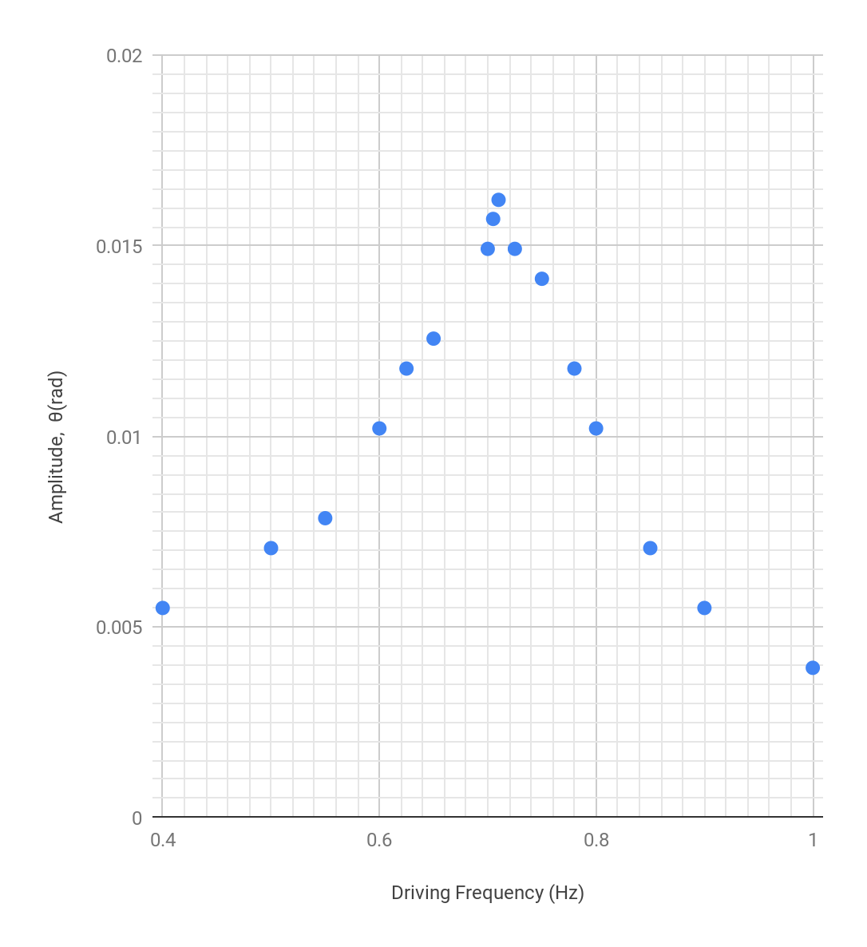

**Figure 6. Resonance Curve for Driven Oscillator.** Each blue data point represents the amplitude in radians of the driven harmonic oscillator for varying driving frequencies.

Where the amplitude is $\frac{1}{\sqrt{2}}$ times the maximum amplitude, and the maximum amplitude is $θ_{max}=0.016V,$ and the two frequencies where the amplitude is expected to be around 0.0113*V* are $ω_{1}=0.625±0.0004 Hz$ and $ω_{2}=0.780±0.0004 Hz$. Then the resonance width, along with its uncertainty, is given by:

${Δω=(ω}_{2}-ω_{1})±\sqrt{δω_{1}^{2}+δω_{2}^{2}}=0.155±0.0006 Hz$

Then Q is estimated to be:

$Q≈\frac{ω_{o}}{Δω}≈\frac{(0.710±0.005) Hz}{(0.155±0.0006) Hz}=4.581±0.04$,

where $δQ=|Q|\sqrt{(\frac{δω_{o}}{|ω_{o}|})^{2}+(\frac{δ(Δω)}{|Δω|})^{2}}=0.04$

The prediction of the Q factors differ by about $0.291±0.20$. This difference can be attributed to errors such as uncertainty in measuring the width of the resonance curve of the driven oscillator.

**Analysis, Waves on a Vibrating Spring**

*Part I: Wave Speed*

Speed *v* of a wave traveling through a string of mass *M* and length *L* under tension *T*:

$v=\sqrt{\frac{T}{μ}}$, for $μ≡\frac{M}{L}$

Variables:

Mass of relaxed string: $m=0.0135±0.0005 kg$

Total length of relaxed string: $L_{relaxed}=1.961 ±0.001 m$

String in the clamp: $L_{clamped}=0.01±0.001 m$

Then

Length of used string: $L_{used}=L_{relaxed}-L_{clamped}=1.951±0.001 m$

Mass of used string: $M_{used}=\frac{m}{L_{relaxed}}*L_{used}=0.0134±0.0005 kg$

|  |  |  |  |
| --- | --- | --- | --- |
| Trial | 1 | 2 | 3 |
| length of stretched string, $L_{stretched} (m)$ | $1.979±0.001$ | $2.002±0.001$ | $2.077±0.001$ |
| linear mass density, $μ (kg/m)$ | $0.00677±0.0003$ | $0.00669±0.0002$ | $0.00645±0.0002$ |
| length of string between pulley and mass, $L_{hanging} (m)$ | $0.360±0.001$ | $0.383±0.001$ | $0.458±0.001$ |
| mass of string between pulley and mass, $m_{hanging} (kg)$ | $0.00244±0.0001$ | $0.00256±0.0001$ | $0.00309±0.0001$ |
| mass of weight, $m_{weight} (kg)$ | $0.3±0.0005$ | $0.4±0.0005$ | $0.5±0.0005$ |
| tension $T(N)$ | $2.9639±0.005$ | $3.945±0.005$ | $4.930±0.005$ |

**Table 1. Properties of the Tensed String** This table displays the measured and derived values of properties that are necessary to describe the string stretched by various masses. $L_{hanging},$ and $m$ are the measured data. All other data and corresponding uncertainties were obtained from the following formulae:

Linear mass density:

$μ=\frac{m}{L_{stretched}}±δμ$

$δμ=|\frac{m}{L_{stretched}}|×\sqrt{(\frac{δm}{m})^{2}+(\frac{δL_{stretched}}{L_{stretched}})^{2}}$

Mass of string between pulley and mass:

$m_{hanging}=(μ×L_{hanging})±δm_{hanging}$

$δm_{hanging}=(μ×L_{hanging})×\sqrt{({\frac{δμ}{μ})}^{2}+(\frac{δL_{hanging}}{L_{hanging}})^{2}}$

Tension:

$T=(m_{hanging}+m_{weight})×g±δT$

$δT=g×\sqrt{{δm}_{hanging}^{2}+{δm}_{weight}^{2}}$

(a)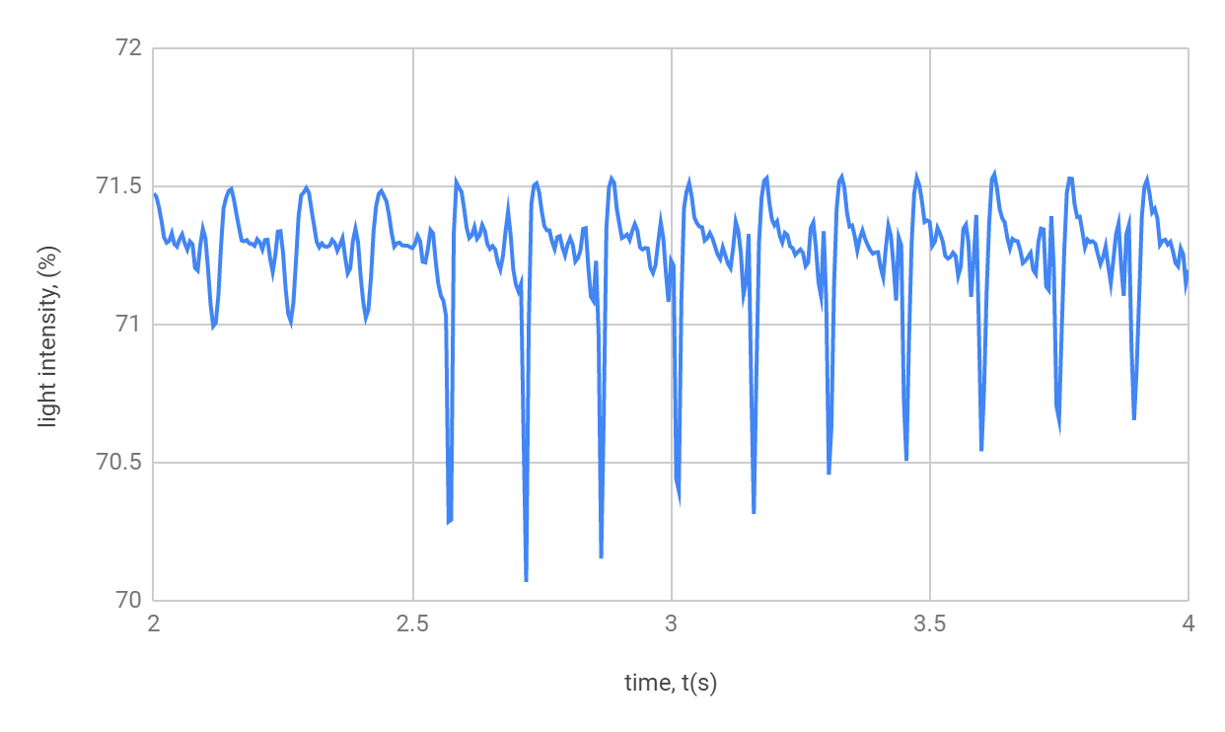

(b)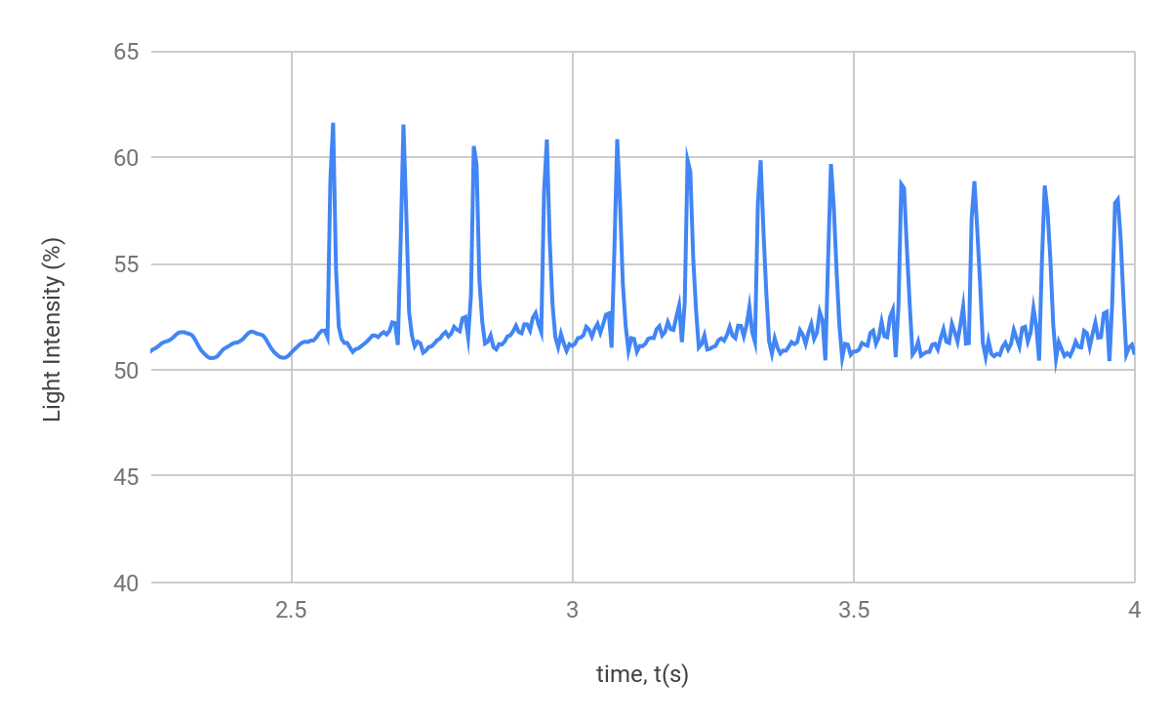

(c)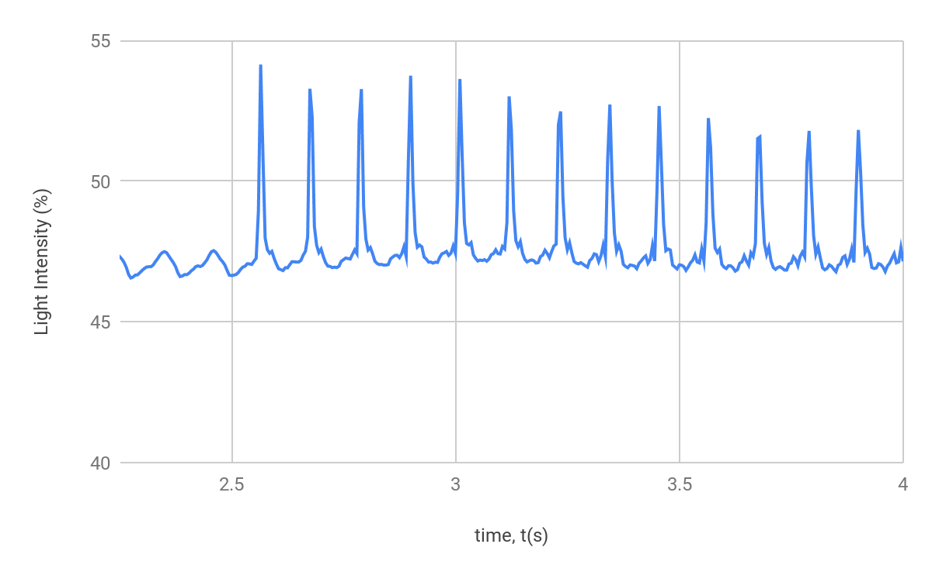

**Figure 7. Determining Wave Speed on String under Varying Tension Forces.** The data in (a), (b) and (c) represent the light intensity detected by the photodiode as vibrations are sent through the string by the wave driver, as the string is put under various tensions as a function of time. In (a), a mass of 0.30 kg is attached to the end, in (b) a 0.40 kg mass is attached, and in (c), a mass of 0.5 kg is attached. .Features in these graphs that are observed to repeat can be used to determine the speed of a wave in the string.

Calculation of Wave Speed for Three Trials:

The predicted wave speed is given by formula: $v_{predicted}=\sqrt{\frac{T}{μ}}±δv$, with uncertainty $δv=|v|×\sqrt{({\frac{δT}{T})}^{2}+({\frac{δμ}{μ})}^{2}}$. To find the measured value of velocity, the change in time is determined by the average of the differences in successive peaks in the graph, and the uncertainty is determined by the standard deviation of the differences. In the fundamental mode, the wavelength is determined by two times the length of string between the clamp and the pulley. The wavelength can be determined by:

$λ={2×(L}_{stretched}-L_{hanging})±δλ$

$δλ=2×\sqrt{(δL_{stretched})^{2}+(δL_{hanging})^{2}}$

Since the distance between the clamp and pulley is unmoved for the three trials, the wavelength for each stays the same.

$λ=3.238±0.003 m$

(a). From the data in Table 1,

Tension in the rope is: $T=2.9639±0.005 N$

Linear mass density is:

$μ=0.00677±0.0003 kg/m$

Using the formula for predicted wave speed,

$v_{predicted}=\sqrt{\frac{2.9639}{0.00677}}±\sqrt{\frac{2.9639}{0.00677}}×\sqrt{({\frac{0.005}{2.9639})}^{2}+({\frac{0.0003}{0.00677})}^{2}}=20.924±0.9 m/s$

To find the measured wave speed, an average of the difference in time between successive peaks is taken, and the uncertainty in time is given by the standard deviation of these values.

$Δt_{avg}=0.147 s$

$δt=\frac{stdev(Δt)}{\sqrt{4}}=\frac{0.00274}{2}=0.001 s$

The measured wave speed can be determined using the following formula:

$v_{measured}=\frac{λ}{Δt_{avg}}±|\frac{λ}{Δt_{avg}}|×\sqrt{({\frac{δλ}{λ})}^{2}+(\frac{δt}{Δt_{avg}})^{2}}$

Plugging in values for wavelength and time,

$v_{measured}=\frac{3.238}{0.147}±|\frac{3.238}{0.147}|×\sqrt{({\frac{0.003}{3.238})}^{2}+(\frac{0.001}{0.147})^{2}}=22.027±0.1 m/s$

(b). From the data in Table 1,

Tension in the rope is: $T=3.945±0.005 N$

Linear mass density is: $μ=0.00669±0.0002kg/m$

Given the variables for tension and linear mass density, the wave speed is given by:

To find the measured wave speed, average period is determined in the same way as it was determined in (a).

$Δt_{avg}=0.126 s$

$δt=\frac{stdev(Δt)}{\sqrt{6}}=\frac{0.00244}{\sqrt{6}}=0.001 s$

To find the measured wave speed, plug in values for $λ$ and $Δt_{avg}$ into the formula for $v_{measured}$.

$v_{measured}=\frac{3.238}{0.126}±|\frac{3.238}{0.126}|×\sqrt{({\frac{0.003}{3.238})}^{2}+(\frac{0.001}{0.126})^{2}}=25.698±0.2 m/s$

(c). From the data in Table 1,

Tension in the rope is: $T=4.930±0.005 N$

Linear mass density is: $μ=0.00645±0.0002 kg/m$

Given the variables for tension and linear mass density, the wave speed is given by:

To find the measured wave speed, average period is determined in the same way as it was determined in (a).

$Δt_{avg}=0.1115 s$

$δt=\frac{stdev(Δt)}{\sqrt{9}}=\frac{0.0024}{3}=0.0008 s$

To find the measured wave speed, plug in values for $λ$ and $Δt_{avg}$ into the formula for $v_{measured}$.

$v_{measured}=\frac{3.238}{0.1115}±|\frac{3.238}{0.1115}|×\sqrt{({\frac{0.003}{3.238})}^{2}+(\frac{0.0008}{0.1115})^{2}}=29.04±0.2 m/s$

|  |  |  |  |
| --- | --- | --- | --- |
|  | Trial 1 | Trial 2 | Trial 3 |
| $v_{predicted}$*(m/s)* | $20.924±0.9$ | $24.284±0.7$ | $27.6467±0.9$ |
| $v_{measured}$*(m/s)* | $22.027±0.1$ | $25.698±0.2$ | $29.04±0.2$ |

**Table 2. Summary of Predicted and Measured Estimations of Wave Velocity.** Here, the results of the calculations from above are summarized in a table.

The measured wave speed values are consistently greater than their predicted counterparts. This could be due to some systematic error present in the setup. However, the trend between each successive trial suggests that increasing tension in the thick string creates waves that propagate faster through the string.

*Part II: Standing Waves*

The equation for the frequency of the nth normal mode is given by the following for *v* is the wave speed, *L* is the distance between the clamp and pulley, and *n=1, 2, 3,...*:

$f=n\frac{v}{2L}$

$δf=\frac{n}{2}×|f|×\sqrt{(\frac{δv}{v})^{2}+({\frac{δL}{L})}^{2}}$

To pin the end of the string at the pulley securely, data from the third trial is used since it had the greatest weight hanging on the end. Thus, for the calculations in this part, $v=29.04±0.2 m/s$.

The distance between the clamp and pulley remains unchanged, so $L=1.619±0.001 m$.

The predicted value for the frequency of the fundamental mode is:

$f_{n=1}=1×\frac{29.04}{2×1.619}±δf_{n=1}=8.968±δf_{n=1} Hz$

$δf_{n=1}=\frac{1}{2}×|8.968|×\sqrt{(\frac{0.2}{29.04})^{2}+({\frac{0.001}{1.619})}^{2}}=0.03 Hz$

The frequencies for higher nodes, say the nth node, is n times the frequency of the fundamental mode. The predicted frequencies for the second and third modes are:

$f_{n=2}=2×8.968±2×0.03 Hz=17.936±0.06 Hz$

$f_{n=3}=3×8.968±3×0.03 Hz=26.904±0.09 Hz$

To measure the frequency for the fundamental and higher modes, Lissajous plots were created in real time, and the driving voltage was adjusted until the Lissajous plot was most symmetric. This is also where the amplitude of the standing wave is greatest. From there, the uncertainty is determined by adjusting the driving frequency until a distortion is observed in the Lissajous plot.

(a)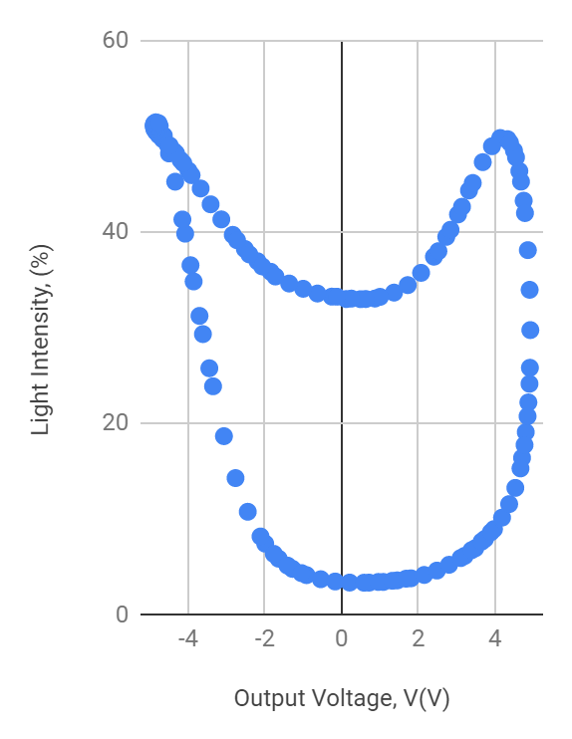(b)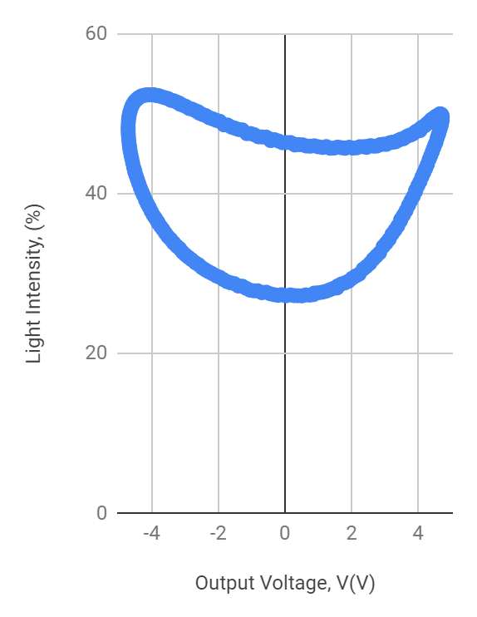

(c)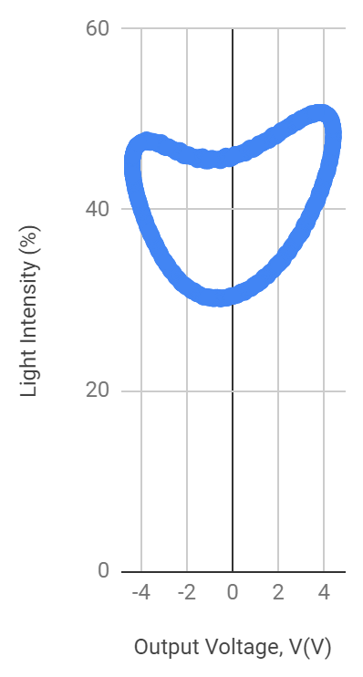

**Figure 8. Lissajous Plots at Various Driving Frequencies.** In each plot, light intensity detected by the photodiode is graphed as a function of the output voltage. Plot (a) is the Lissajous plot at fundamental frequency, (b) is the plot at n=2, and (c) is the plot at n=3.

The measured frequencies which most maximizes the amplitude of the wave and symmetry in the Lissajous plot are:

$f_{n=1}=8.980±0.01 Hz$

$f_{n=2}=17.96±0.01 Hz$

$f_{n=3}=26.93±0.01 Hz$

The measured frequencies were consistently slightly greater than the predicted frequencies. However, the measured and predicted frequencies agree with each other.

*Extra Credit*

At n=15, the string is still visibly vibrating, and nodes and antinodes are countable. At 60, the string appears to remain perfectly still, and the only sign of a vibration in the string is the high pitched sound which is produced. When we lowered the frequency, the maximum mode at which we could still count the nodes was at n=18. At n=19 and n=20, nodes closest to the clamp and pulley were identifiable, but nodes farther from the clamp no longer identifiable (perhaps because of the energy loss as the vibrations propagate through the string).

**Conclusion**

A damped, oscillating pendulum and stretched string were used in this experiment to investigate the properties of oscillators. With the pendulum we investigated underdamped, overdamped, and critically damped systems. With the string, we investigated wave speed and its relation to tension in the thick string and the behavior of standing waves.

Without any external forces from damping or driving, the undamped resonance frequency of the pendulum was determined to be $ω_{o}=0.710±0.005 Hz$. In determining critical damping in the pendulum, the magnets were spaced 15.5 mm apart, and the driving resonance frequency could not be predicted from formulae alone because compex values were predicted for the driven resonance frequency, most likely due to experimental set up error. However, driving resonance frequency, and hence the quality factor Q, could still be determined from Lissajous figures ($Q=4.290±0.2$) and from the resonance curve for the driven oscillator ($4.581±0.04$). The difference can be attributed to errors in experimental setup, in combination with estimations of the width of the resonance curve.

In the setup of the vibrating spring, various masses were hung from the end to vary the tension in the spring, and then wave velocities in the rope were predicted and calculated. The data is summarized in Table 2. In studying standing waves in this set up, the fundamental node was determined by creating a Lissajous figure in real time as the driving frequency was adjusted until the figure was most symmetric. Then frequencies of higher modes were predicted by taking integer multiples of the first, and compared with measured frequencies. The uncertainty was measured by adjusting the frequencies slightly above and below the measured mode until distortion became observable in the Lissajous figure. The measured frequencies were consistently higher than predicted frequencies.

**Works Cited**

[1] Campbell, W.C. et al. Physics 4AL: Mechanics Lab Manual. UCLA Department of Physics and Astronomy. 64:64. 2018.